Frequently asked questions regarding snow plowing and winter road conditions.

This information will help you better understand our snow removal policies and procedures. We encourage you to review these questions before contacting us.
During storms, our team is typically very occupied, and we aim to use our time (and your tax dollars) efficiently by concentrating on plowing instead of addressing repeated inquiries from residents.
In the event of a medical emergency please dial 911 and all necessary steps will be coordinated to get emergency personnel to you. The potential for a medical emergency does not warrant priority treatment.

What is a “Snow Alert?”
The City of Harrisburg will issue a “Snow Alert” when an accumulation of 2 inches is either anticipated or when snowplows are dispatched without prior forecast warnings. This alert may also encompass conditions such as blowing or drifting snow that necessitate plowing. We will communicate both the start and end times of the alert, and it may be extended or lifted based on prevailing conditions.
How is a Snow Alert Communicated?
The City of Harrisburg communicates via several mediums including:
- TextMyGov notifications
- City Website
- Social Media
- KELO-TV
- KSFY-TV
Why can't you plow my street first?
We would like to have sufficient snowplows and drivers to promptly clear every street; however, our resources are limited. Therefore, we must follow a structured system for snow removal. Allowing plows to divert for special requests would significantly prolong the time required to clear all city streets. To maintain the efficiency and effectiveness of our snow removal operations, plows are restricted from deviating from their assigned routes. The Primary Snow Route streets are prioritized for plowing snow (please see map Snow Information | City of Harrisburg )
Can you tell me exactly when my street will be plowed?
Under optimal conditions, we can reasonably predict when various sections of the city will be cleared of snow. However, as weather conditions fluctuate, we may need to adjust our snow removal strategy during operations to effectively manage drifting snow, ice, and other specific challenges. Consequently, we are unable to provide an exact timeline for when your street will be cleared, given the unpredictable nature of the weather.
Why don't the trucks plow and sand/salt on the way to their routes?
Each snowplow is assigned a specific route to ensure efficiency. If the trucks were to spread sand or salt en route to their destination, they would deplete their supplies before reaching their designated area. Additionally, plowing along the way would extend the time it takes for the truck to arrive at its assigned route. Therefore, the application of sand and salt is conducted only after the streets have been thoroughly plowed.
Who is responsible for plowing Willow, Cliff, Southeastern and Minnesota Ave?
The city is responsible for plowing all streets within Harrisburg City limits.
Willow Street
- City of Harrisburg
    - Minnesota Ave east to Southeastern Ave
- Lincoln County
    - Minnesota Ave west
    - Southeastern Ave east
Cliff Ave
- City of Harrisburg
- 274th north to Black Dog Storage
- LaValley Township
- South of 274th
- Lincoln County
- North of Black Dog Storage
Southeastern Ave
- City of Harrisburg
- 274th north to 272nd
- Springdale Township
- North of 272nd
- LaValley Township
- South of 274th
Minnesota Ave (HWY 115)
- South Dakota Department of Transportation

Contact Numbers:
City of Harrisburg 605-743-5872
Lincoln County 605-764-5841
SD Department of Transportation 605-773-3265
Springdale Township 605-743-2962
LaValley Township 605-295-2532

Additionally, please be respectful to ALL road crews. Given the amount of area that needs to be covered, please understand that not everyone can be served first.
What about cul-de-sacs?
Cul-de-sacs pose significant challenges for snow plowing, often ranging from difficult to nearly impossible. While a plow can smoothly cut an 11-foot path on a straight road, maneuvering and turning the blade within the confined space of a cul-de-sac is quite challenging and time-consuming. The most effective approach to clearing cul-de-sacs differs by neighborhood and may necessitate a return visit to address the snow piles that have formed.
Why do you sometimes salt instead of plow, or plow instead of salt?
Different storm types necessitate various snow-fighting strategies. The choice to salt or plow hinges on anticipated weather conditions. For instance, if temperatures are below 20 degrees and not expected to rise, salting will not be effective. However, if the sun is shining and temperatures are at or above 20 degrees, with a steady or increasing trend, salting becomes a viable option. Decisions regarding plowing or salting are made thoughtfully, relying on the most current weather data. Plowing under inappropriate conditions can lead to a slick street surface, creating hazardous glare ice. The choices made by our skilled crew and supervisory staff are essential for safety.
The plow left snow at the end of my driveway. Why can’t the city just move it?
There are over 2,500 driveways in Harrisburg. If we deployed all our snowplows and dedicated just 60 seconds to each driveway, it would take us several days to clear them all. To help alleviate this issue, consider piling the snow you've shoveled from your driveway on the downstream side. This way, if the snowplow encounters the pile, it will push the snow onto the grass or sidewalk instead of back into your driveway.
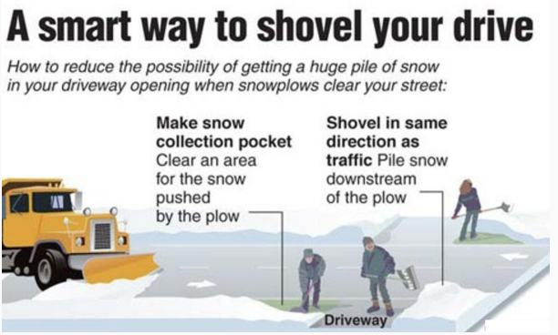

When is parking prohibited on city streets?
When a snow alert is declared, the city lists “begin” and “end” times. During the entire snow alert period, vehicles may be subject to ticketing and/or towing at any time.
I got a ticket, but my neighbor did not. How does that happen?
During a snow alert, the Lincoln County Sheriff’s Office fulfills multiple roles. They may begin issuing tickets but can be diverted to respond to an accident or another emergency, returning hours later to resume ticketing. Consequently, this is not a continuous process. Residents should be aware that ticketing and towing can occur at any time during the snow event, even if the street has already been cleared.
If the street has been cleared, why can I still get a ticket?
Our snowplows and trucks make several passes on the roads and need access to all streets (secondary roads, cul de sacs, etc.) during the entire event. That is the reason for the “end” time. Please note that conditions change and sometimes the “end” time needs to be extended. It is your responsibility to stay informed of any changes.

